**Slide1**

**Religion**

Religion is an institution made up of beliefs, practices, and values that deal with the difference between the seen world (what we can touch and see) and the unseen world (like God, spirits, or heaven).

**Slide2**

**Elements Of Religion:**

**Belief**: Core ideas or principles that followers accept as true and sacred.

Examples:

Belief in a higher power (like God, Allah, Bhagwan).

**Sacred Books**: Holy writings that contain the teachings, laws, stories, and wisdom of a religion.

Examples:

Holy books such as the **Qur’an**, **Bible**, **Gita**, or **Torah**.

**Sacred Places:** Specific locations considered holy and used for worship or spiritual practice.

Examples:

Places like mosques, temples, churches, or shrines.

**Ritual:** Formal actions or ceremonies performed regularly as expressions of belief.

Examples:

Religious actions like prayer, fasting, pilgrimage, or offerings.

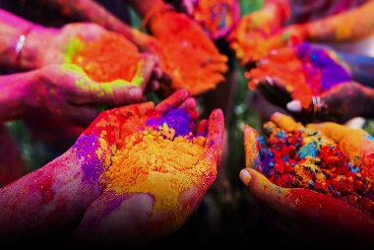 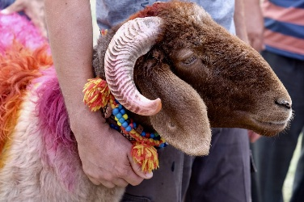 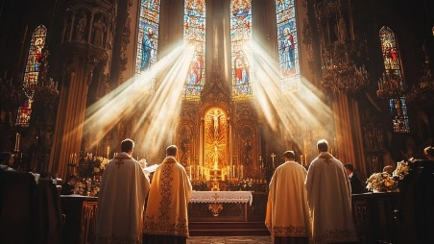

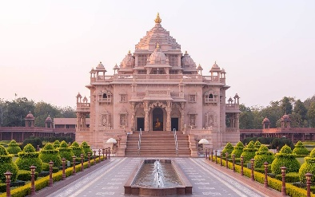 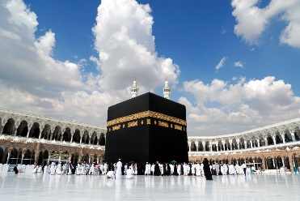 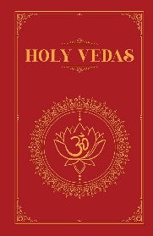

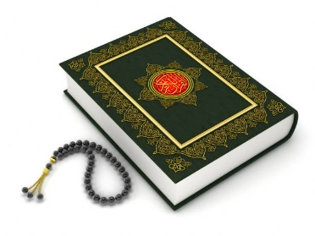 

**Slide3**

**Types Of Religion:**

* **Monotheism**: Belief in only one God who controls everything.  
  (e.g., Islam, Judaism)
* **Polytheism**: Belief in many gods, each with different powers.  
  (e.g., Ancient Greeks and Romans)
* **Multitheism**: Belief in worshipping many idols as forms of gods.  
  (e.g., Ancient Arabia, Hinduism in India)

**Slide4**

**Types Of Religion:**

* **Tritheism**: Belief in **God, Jesus, and the Holy Spirit as three gods.**  
  (e.g., Christianity)
* **Animism**: Belief that **animals, plants, and nature have spirits.**  
  (e.g., Shintoism, tribal religions)
* **Totemism**: Belief that **some people like chiefs or kings have special powers.**  
  (e.g., Ojibwa – First Nations)

**Slide5**

**No Religion/Not To Religion:**

There is large no of people who do not support, believe or accept any religion.

They are:

**Atheist**: Personally does not believe in religion

**Secular**: Neutral about religion in public life

**Slide6**

**Difference Between Atheist & Secular:**

**Secular**

Secular means not connected to religion. A secular person may believe in a religion personally but supports keeping religion separate from government, education, or public matters.

Example: A secular school doesn’t teach religious content.

**Atheist**

A person who does not believe in God or any religion. An atheist thinks there is no divine being or higher power.

Example: An atheist doesn’t pray or follow any religious practices.

**Slide7**

**Major Religions of the World:**

**Christianity:** A faith based on the teachings of Jesus Christ, emphasizing love, salvation, and belief in one God.

**Islam:** A monotheistic religion based on the teachings of Prophet Muhammad (PBUH), guiding all aspects of life through the Quran.

**Hinduism:** An ancient religion centered on karma, rebirth, and devotion to multiple deities.

**Buddhism:** A path of spiritual development based on the teachings of Gautama Buddha, focusing on ending suffering through mindfulness and ethical living.

**Slide9**

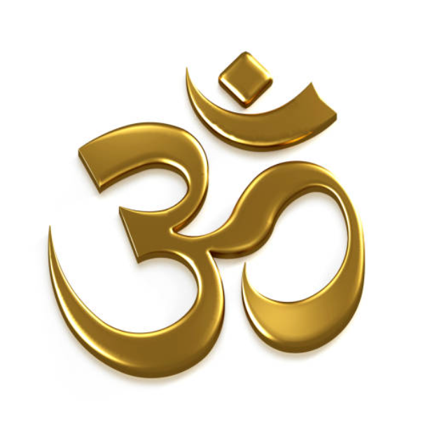 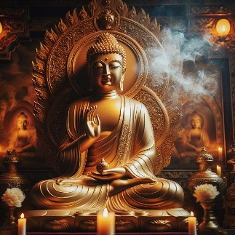  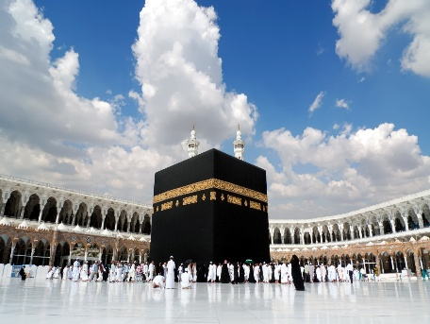

**Slide10**

**Functions Of Religion:**

* Religion helps people understand the **purpose of life**, death, and the universe.
* It teaches what is **right and wrong**.
* Religion create relation between Man and Allah.
* Religion brings people together in a **community**, especially during festivals, prayers, or rituals.
* Prayer, worship, and faith give people peace of mind.
* Religion helps pass traditions**,** stories**,** andvalues from one generation to the next.
* Religious rules and practices (like fasting, praying on time) buildself**-**control and routine in life.

**Slide11**

**Religion In Pakistan:**

* Islam is the main religion
* Other religions are respected
* Different Islamic sects live together
* Message of peace
* One nation, many faiths